“The Lottery” Anticipation Guide Name ______________________ Hour ______ Date _________
NUMBER | STATEMENT | AGREE | DISAGREE
1 | Winning the lottery is always a good thing.
1
2 | One should always follow authority without question.
2
3 | Children have no choices in their lives. They do what adults tell them to do.
3
4 | All traditions are important and should never be forgotten.
4
5 | Given no other option, I would sacrifice one human life if it meant saving others.
5
6 | I sometimes allow others to take the blame for something I have done wrong.
6
7 | When I hear of something bad happening to someone else, I’m secretly relieved that it’s not happening to me.
7
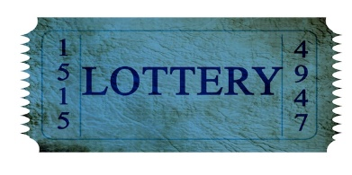
Check agree or disagree for each of the following statements. Then, in the space below, explain your rationale or point of view for that statement. In your explanation, include specific evidence/examples. Your example can come from literature, historical events, pop culture, or personal experiences. Please be aware that you WILL be sharing your examples.

