Sophie Scholl and the White Rose: Dissent in Nazi Germany

In 1942, a group of university students in Munich set out to do what few Germans had dared - defy Hitler. They knew from the start that were they to be caught, it would mean certain death, and yet they acted anyway. Calling themselves the "White Rose," they set out to build up popular resistance to the Nazi regime by distributing leaflets throughout Germany urging Germans to resist by any means.
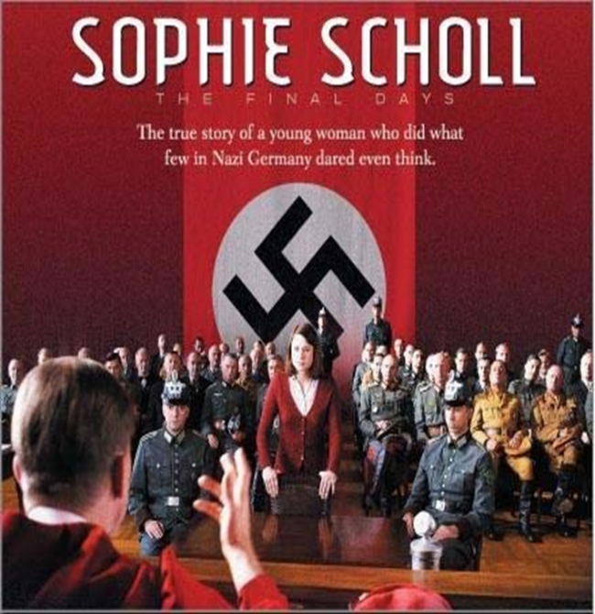
Today in Germany, one of the most popular heroes is Sophie Scholl. She is greatly admired for the bold and courageous actions she took to defy the Nazi regime. She and several other members of the White Rose, clandestinely published and distributed anti-Nazi literature. Between the early summer of 1942 and February 1943, people in cities in the South of Germany and in Austria found leaflets in their mail boxes calling for protests against the Nazi regime. On February 19, 1943, Hans and Sophie took a great risk by placing copies of a sixth leaflet produced by the White Rose in the deserted halls of the University of Munich.

While you are watching, consider the following questions:
- What kind of resistance activity was the White Rose involved in? Why did they stop?
- Who were considered “enemies of the state” in Nazi Germany? How does a janitor have the right to arrest anyone?
- What was the Nazi response to the student movement when they discovered it?
- What was Sophie’s response to the interrogation?
- Was Sophie treated fairly? What do you recognize as legitimate and illegitimate treatment of an alleged criminal and court proceedings?
- What was the outcome of the trial? Why did it happen the way it did?

After watching, consider these questions:
- Why it is important to remember this story?
- Why was it was necessary for these students to protest? What happens when a government restricts the freedom of speech and other civil liberties?
- What is your response to the following quotes?
“A state that suppresses all freedom of speech, and which by imposing the most terrible punishments, treats each and every attempt at criticism, however morally justified, and every suggestion for improvement as plotting to high treason, is a state that breaks an unwritten law.” (Kurt Huber)
“There is a point at which the law becomes immoral and unethical. That point is reached when it becomes a cloak for the cowardice that dares not stand up against blatant violations of justice.” (Kurt Huber)
“Long live the Freedom!” (Hans Scholl)
“We will not be silent. We are your bad conscience. The White Rose will not leave you in
Peace.” (Leaflet four authored by Hans Scholl and Alexander Schmorell)
“What we have said and what we have written is what so many people believe only they don’t dare to speak up.” (Sophie Scholl)

More about the White Rose
- https://www.jewishvirtuallibrary.org/the-white-rose-a-lesson-in-dissent
- http://www.katjasdacha.com/whiterose/
- http://www.fff.org/freedom/0196a.asp
- The book, Sophie Scholl and the White Rose, by Annette Dumboch and Jud Newborn
- http://www.jlrweb.com/whiterose/
Text of the White Rose Leaflets: http://www.holocaustresearchproject.org/revolt/wrleaflets.html
German Resistance
- https://www.ushmm.org/wlc/en/article.php?ModuleId=10005208
- https://www.ushmm.org/wlc/en/article.php?ModuleId=10005420

