From the Folger Shakespeare Library

Shakespeare's Life
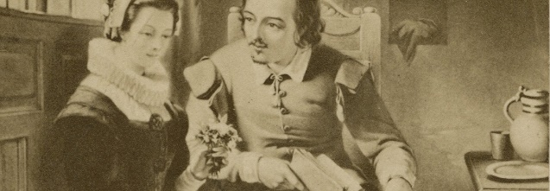
Since William Shakespeare lived more than 400 years ago, and many records from that time are lost or never existed in the first place, we don't know everything about his life. For example, we know that he was baptized in Stratford-upon-Avon, 100 miles northwest of London, on April 26, 1564. But we don't know his exact birthdate, which must have been a few days earlier.
We do know that Shakespeare's life revolved around two locations: Stratford and London. He grew up, had a family, and bought property in Stratford, but he worked in London, the center of English theater. As an actor, a playwright, and a partner in a leading acting company, he became both prosperous and well-known. Even without knowing everything about his life, fans of Shakespeare have imagined and reimagined him according to their own tastes, just as we see with the 19th-century portrait of Shakespeare wooing his wife at the top of this page.

Birth and childhood
William Shakespeare was probably born on about April 23, 1564, the date that is traditionally given for his birth. He was John and Mary Shakespeare's oldest surviving child; their first two children, both girls, did not live beyond infancy. Growing up as the big brother of the family, William had three younger brothers, Gilbert, Richard, and Edmund, and two younger sisters: Anne, who died at seven, and Joan.
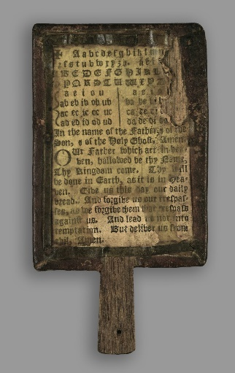
Their father, John Shakespeare, was a leatherworker who specialized in the soft white leather used for gloves and similar items. A prosperous businessman, he married Mary Arden, of the prominent Arden family. John rose through local offices in Stratford, becoming an alderman and eventually, when William was five, the town bailiff—much like a mayor. Not long after that, however, John Shakespeare stepped back from public life; we don't know why.
Shakespeare, as the son of a leading Stratford citizen, almost certainly attended Stratford's grammar school. Like all such schools, its curriculum consisted of an intense emphasis on the Latin classics, including memorization, writing, and acting classic Latin plays. Shakespeare most likely attended until about age 15.

A horn book, similar to one that Shakespeare might have learned to read from.

Marriage and children
A few years after he left school, in late 1582, William Shakespeare married Anne Hathaway. She was already expecting their first-born child, Susanna, which was a fairly common situation at the time. When they married, Anne was 26 and William was 18. Anne grew up just outside Stratford in the village of Shottery. After marrying, she spent the rest of her life in Stratford.
In early 1585, the couple had twins, Judith and Hamnet, completing the family. In the years ahead, Anne and the children lived in Stratford while Shakespeare worked in London, although we don't know when he moved there. Some later observers have suggested that this separation, and the couple's relatively few children, were signs of a strained marriage, but we do not know that, either. Someone pursuing a theater career had no choice but to work in London, and many branches of the Shakespeares had small families.
Shakespeare's only son, Hamnet, died in 1596 at the age of 11. His older daughter Susanna later married a well-to-do Stratford doctor, John Hall. Their daughter Elizabeth, Shakespeare's first grandchild, was born in 1608. In 1616, just months before his death, Shakespeare's daughter Judith married Thomas Quiney, a Stratford vintner. The family subsequently died out, leaving no direct descendants of Shakespeare.
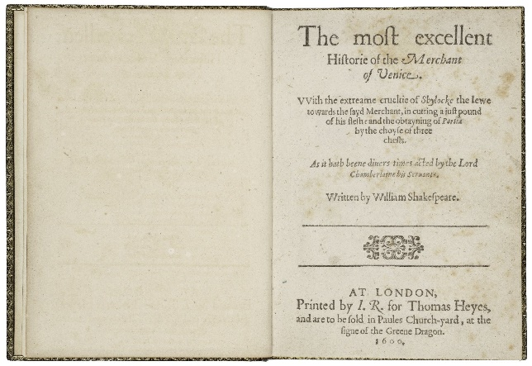
1600 Quarto of Merchant of Venice.

London theater
For several years after Judith and Hamnet's arrival in 1585, nothing is known for certain of Shakespeare's activities: how he earned a living, when he moved from Stratford, or how he got his start in the theater.
Following this gap in the record, the first definite mention of Shakespeare is in 1592 as an established London actor and playwright, mocked by a contemporary as a "Shake-scene." The same writer alludes to one of Shakespeare's earliest history plays, Henry VI, Part 3, which must already have been performed. The next year, in 1593, Shakespeare published a long poem, Venus and Adonis. The first quarto editions of his early plays appeared in 1594. For more than two decades, Shakespeare had multiple roles in the London theater as an actor, playwright, and, in time, a business partner in a major acting company, the Lord Chamberlain's Men (renamed the King's Men in 1603). Over the years, he became steadily more famous in the London theater world; his name, which was not even listed on the first quartos of his plays, became a regular feature—clearly a selling point—on later title pages.
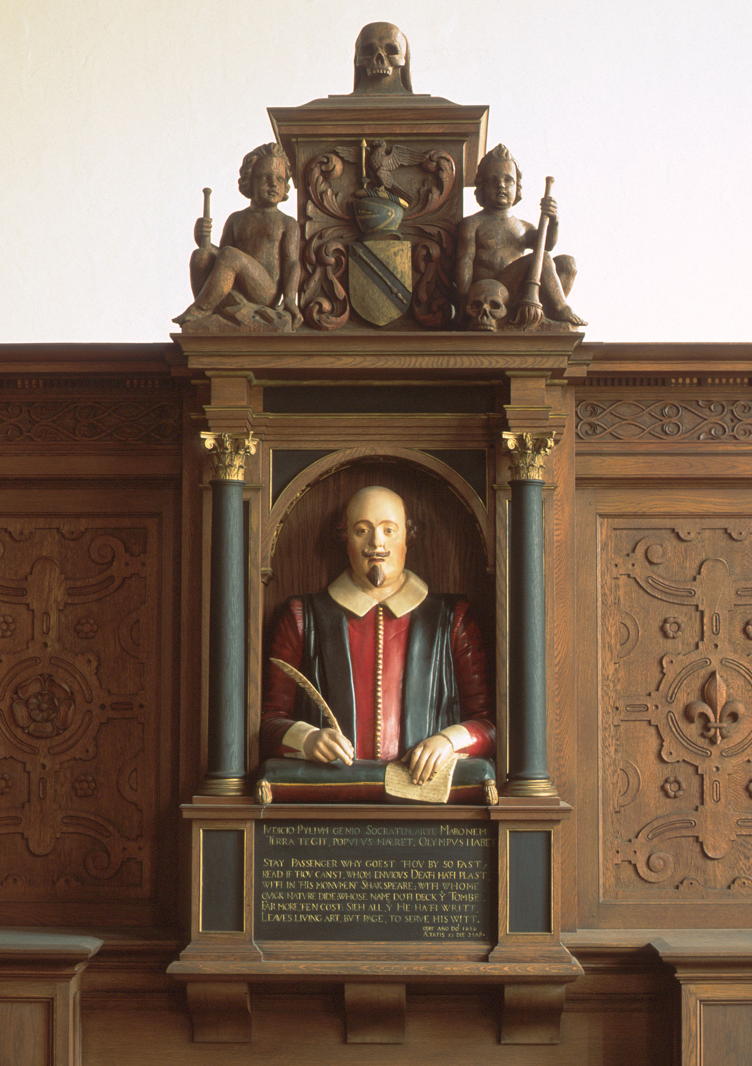
Shakespeare's Bust in the Folger's Paster Reading Room

Final years
Shakespeare prospered financially from his partnership in the Lord Chamberlain's Men (later the King's Men), as well as from his writing and acting. He invested much of his wealth in real-estate purchases in Stratford and bought the second-largest house in town, New Place, in 1597.
Among the last plays that Shakespeare worked on was The Two Noble Kinsmen, which he wrote with a frequent collaborator, John Fletcher, most likely in 1613. He died on April 23, 1616—the traditional date of his birthday, though his precise birthdate is unknown. We also do not know the cause of his death. His brother-in-law had died a week earlier, which could imply infectious disease, but Shakespeare's health may have had a longer decline.
The memorial bust of Shakespeare at Holy Trinity Church in Stratford is considered one of two authentic likenesses, because it was approved by people who knew him. (The bust in the Folger's Paster Reading Room, shown at left, is a copy of this statue.) The other such likeness is the engraving by Martin Droeshout in the 1623 First Folio edition of Shakespeare's plays, produced seven years after his death by his friends and colleagues from the King's Men.

Shakespeare FAQ
The following Frequently Asked Questions about Shakespeare's life and works are based on the many questions the Folger receives from the public.
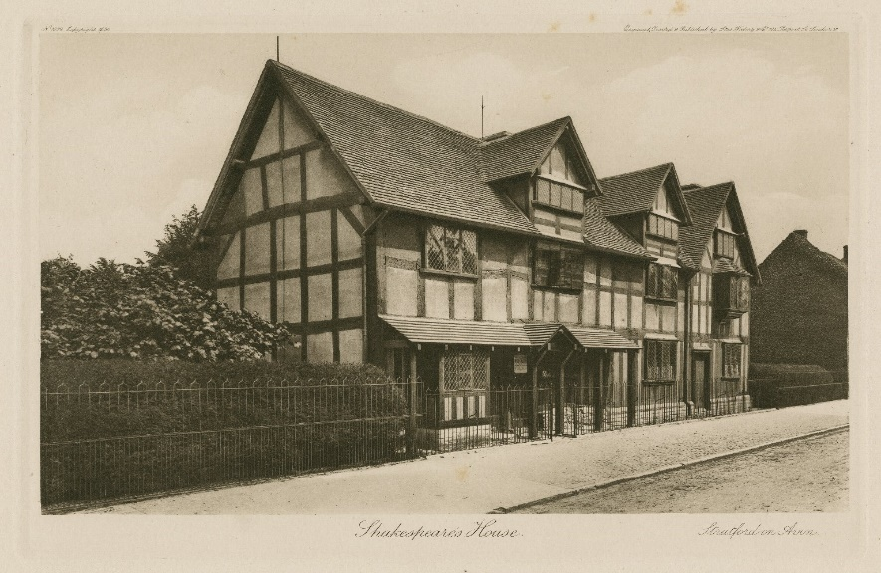
1896 print of Shakespeare's birthplace by Stas Waley & Co.

Shakespeare’s life and family
When and where was Shakespeare born?
Shakespeare was born in Stratford-upon-Avon, England, in 1564. The exact date of his birth isn't known, but it is generally celebrated on April 23. We do know that he was baptized on April 26, and it was common practice at the time to have an infant be baptized no later than the first Sunday after birth.
What was Shakespeare's education?
He likely attended the local grammar school, beginning at age 7, although he probably had learned his letters and basic reading before then. There is no record of him attending university.
Who were Shakespeare's parents and siblings?
Shakespeare's parents were John and Mary (neé Arden), who were married in about 1557. William was the oldest surviving child; two infant daughters died before William was born. William's younger siblings were Gilbert (born in 1566), Joan (1569), Anne (1571), Richard (1574) and Edmund (1580). Ann died at the age of eight, but the others lived into their adulthoods.
Who was Shakespeare's wife?
Shakespeare married Anne Hathaway near the end of 1582, when he was 18 years old. The exact date of Anne's birth is unknown, but she is thought to have been around 26 when they married.
Why did Shakespeare leave his wife his "second best bed"?
William Shakespeare wrote in his last will and testament, dated March 25, 1616, "Item I gyve unto my wife my second best bed with the furniture" (furniture is used to refer to the curtains and bedcover which formed part of the complete bed).
This was not an unusual bequest, nor was it likely to have been intended as a snub. The best bed was usually regarded as an heirloom piece, to be passed to the heir rather than the spouse. It is also probable that the best bed would have been reserved for guests, meaning the "second best" was the bed that William and Anne shared.
What did Shakespeare’s son die of?
We don't really know how Shakespeare's young son Hamnet died. He had a twin sister named Judith, who lived to adulthood and married, but Hamnet died at the age of 11 and a half. Child mortality was high in the sixteenth century; there were no antibiotics and many childhood diseases might therefore prove fatal, such as scarlet fever, whooping cough, diphtheria, and even measles. He was buried on August 11, 1596.
When did Shakespeare die?
Shakespeare died on April 23, 1616 and was buried on April 25, 1616 in Holy Trinity Church, Stratford-upon-Avon.
What is the inscription on Shakespeare’s grave?
GOOD FREND FOR JESUS SAKE FORBEARE,
TO DIGG THE DUST ENCLOASED HEARE:
BLESTE BE Ye [the] MAN Yt [that] SPARES THES STONES,
AND CURST BE HE Yt [that] MOVES MY BONES.
Does Shakespeare have descendants?
William Shakespeare and Anne Hathaway had three children.
The eldest, Susanna, was baptized on May 26, 1583, and married John Hall in 1607. They had one child, Elizabeth, in 1608. Elizabeth was married twice, to Thomas Nash in 1626, and to John Bernard in 1649. However, she had no children by either husband.
William and Anne also had twins, Judith and Hamnet, who were baptized on February 2, 1585. Hamnet died at age 11 and a half.
Judith married Thomas Quiney in 1616, and the couple had three sons: Shakespeare Quiney, who died in infancy, and Richard and Thomas, who both died in 1639 within a month of each other. Since neither of the boys married, there is no possibility of any legitimate descendants from Shakespeare's line.
It is possible, however, to claim a relationship to Shakespeare through his sister, Joan. She married William Hart some time before 1600 and there are many descendants of this marriage alive today, in both the male and female lines.
Did Shakespeare have a coat of arms?
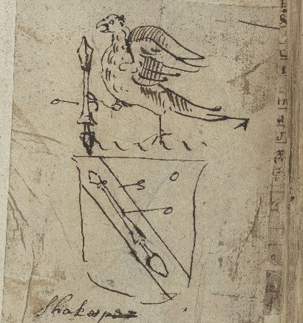
Yes, William's father, John Shakespeare, was granted a coat of arms in 1596. It was disputed in 1602 by York Herald, Ralph Brooke, saying that the arms were too similar to existing coats of arms, and that the family was unworthy. However, the challenge seems to have been unsuccessful, as the Shakespeare crest appears in later collections of coats of arms and on William Shakespeare's funeral monument in Holy Trinity Church, Stratford-upon-Avon.

Sketch of Shakespeare's coat of arms

Shakespeare's works
Did Shakespeare write the plays and poems attributed to him?
Some have argued that a more noble writer was secretly behind the works attributed to Shakespeare; they doubt that someone without an aristocratic pedigree could have written the plays and poetry published under his name. Since the 19th century, several candidates for "hidden author" have been proposed, among them Queen Elizabeth, Sir Francis Bacon, and Edward de Vere (earl of Oxford). Such debates testify to the lasting importance of Shakespeare's works and call attention to the astonishing achievement that they represent.
In the century since these claims were first advanced, no decisive evidence has been unearthed proving that the plays were produced by anyone but the man from Stratford-upon-Avon, a man equipped with a very good "grammar-school" education and the experience gained working in a professional theater company in London.
The Folger has been a major location for research into the authorship question, and welcomes scholars looking for new evidence that sheds light on the plays' origins. How this particular man—or anyone, for that matter—could have produced such an astounding body of work is one of the great mysteries.
How many words did Shakespeare write?
According to Marvin Spevack's concordances, Shakespeare’s complete works consist of 884,647 words and 118,406 lines.
How many plays did Shakespeare write?
Thirty-eight is the generally accepted number, though recent claims have been made for King Edward III and some scholars would include part of Sir Thomas More. Another play, Cardenio, has not survived.
What is Shakespeare’s earliest play?
His earliest play is probably one of the three parts of King Henry VI (Part 1, Part 2, and Part 3), written between 1589–1591.
What is Shakespeare’s last play?
His last play is probably The Two Noble Kinsmen, which Shakespeare co-wrote with John Fletcher around 1613.
What is Shakespeare’s longest play?
Hamlet, with 4,042 lines.
What is Shakespeare’s shortest play?
The Comedy of Errors, with 1,787 lines.
What is the "First Folio"?
The First Folio is the first comprehensive collection of Shakespeare's plays, containing 36 of the 38 plays we now consider to be his. It was published in 1623, seven years after Shakespeare's death, by some of the actors from his company. It was the first time a number of Shakespeare's plays, including Macbeth and As You Like It, were published at all. Without the First Folio we might have only about half of the plays that Shakespeare ever wrote.
How were Shakespeare's plays published before the First Folio?
Many of the plays were published during Shakespeare's lifetime as individual plays in a quarto format.
What are folios and quartos?
"Folio" and "quarto" refer to the number of times a sheet of paper has been folded for printing, and thus gives a rough indication of the size of the book.
A folio is a book for which the initial sheet of paper has been folded in half, providing two leaves and four pages (the front and back of each leaf) for printing.
A quarto is folded again, giving four leaves and eight pages.
How many First Folios still exist?
The easiest answer to this question is 235. Anthony West counts 232 in his 2001 census of First Folios. In 2014, a previously uncounted copy was discovered in France, and in 2016 two more came to light in Britain. But the full answer is more complicated: there are additional copies whose whereabouts aren’t currently known, and differentiating between a complete copy and a fragment of a First Folio can be tricky.
Who has the most First Folios?
The Folger Shakespeare Library has 82 First Folios, the most in one collection. Meisei University in Tokyo has the second largest collection, with 12.

