Prep Check—Week 1: Due Thursday, 8/26/2021

In order to prepare for a new year of learning using online and physical tools, we will set up and practice using our electronic the tools and make certain we have the physical tools we need for success. These activities will ensure that your technology is up to date, you know how to navigate it, and you know how to contact me.
Please use your Stream or personal laptop to complete these tasks. Talk to a peer or me to help you with these tasks.
As you complete each task, mark that it is complete (choose a feature in Word that will allow you to mark of the page like highlighting or using strikethrough). When you finish the entire list, you will send your checklist to me in Teams. (Completed Check list: 5 points)
- Go to my website (karalycke.weebly.com):
- Bookmark this site on your Stream/laptop’s browser.
- Open One Drive from the file icon at the bottom of your screen.
  - Create a new folder. Change to title of the folder to our class name and school year (e.g., ENG2 2021-2022, AP Lang 2021-2022, or IB ENG3 2021-2022)
  - Return to my website and open the syllabus for your class. Save it in the new folder you just made for English class in One Drive.
- Find the Remind code for your English class on my website.
  - Sign up for your English class Remind. Use your real name so I know who you are when you send me messages.
  - Send me a remind message about what keeps you busy when you are not in the classroom. What activities are you involved in both in and out of school? Are you in a club or sport? Do you have a job, responsibilities at home? Remind is more informal than an email, so you can write like you are writing a text message. Remember, though, I am your teacher , so use school-style language. (5 points)
- Open MS Outlook:
  - Send me (kara.lycke@psd150.org) a professional academic email. (5 points)
  - Write a brief response to this prompt. You do NOT have to answer every question but tell me what you think is important for me to know: We tried many approaches to learning last year: online, hybrid, and in-person. We also tried lots of new electronic tools and tricks.
    - What are your thoughts about these different approaches to learning? What was your favorite/least favorite and why?
    - Are there any technology tools you especially liked or did not like?
    - How do you feel your learning was supported and/or where could you have used more help?

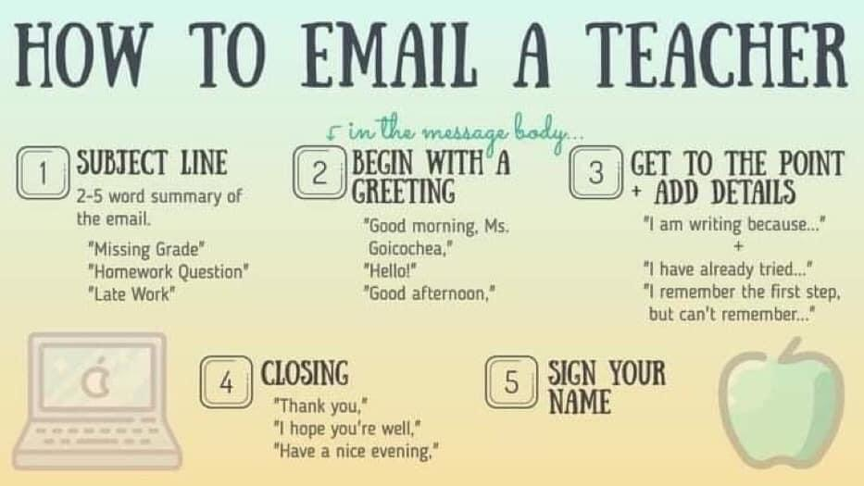
- Go to your assignments for English class in Teams.
  - Find and complete the First Week Survey. (5 points)
- Return to the syllabus and look to see what supplies you will need for class. Gather those supplies and show me that you have them all. Start bringing them to class every day! (5 points)
- AP students only: Go to the College Board website (collegeboard.org).
  - Bookmark the login page for the My AP page.
  - Join your class following the instructions on my website using the correct code. (5 points)
  - If you are in more than one AP class and you already have a My AP account, make sure you are signed up for AP English Language and Composition.
- When you have completed all the tasks for this assignment, do the following:
  - Save the marked-up document in your English OneDrive folder. Change the file name so that it follows this format: LastNameClassPeriodAssignmentName. For example, Atwood1PrepCheck.
  - Submit this checklist (the file you just saved with a new name) to our class assignments in Teams. Be sure you have marked up the document and changed the file name. (5 points)
Prep Check Assignment Rubric
_____ /5 Checklist turned in through Teams
_____ /5 Remind message
_____ /5 Email—correct format and content
_____ /5 First Week Survey completed
_____ /5 Supplies for class in hand
_____ /5 AP STUDENTS ONLY – Join the AP Language and Composition Course on My AP
_____ /25 total (30 for AP students) Grade = _____

