Langston Hughes Poetry Activity: English 2

Harlem
by Langston Hughes

What happens to a dream deferred?
Does it dry up
like a raisin in the sun?
Or fester like a sore—
And then run?
Does it stink like rotten meat?
Or crust and sugar over—
like a syrupy sweet?
Maybe it just sags
like a heavy load.

Or does it explode?

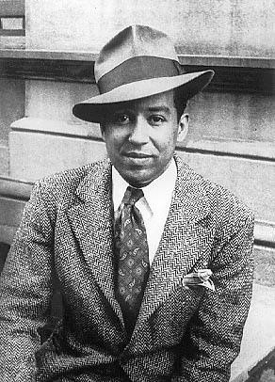

“Harlem: What Happens To A Dream Deferred?” is one of a number of poems Langston Hughes wrote that relates to the lives of African American people in the USA. The poem poses questions about the hopes of a people and the consequences that might arise if those dreams and hopes aren’t achieved. Hughes also wrote novels, stories, essays, and articles throughout his career, but it was mainly as a poet that he gained recognition. He wanted his poems to reflect the plight of black Americans and to give them a voice. Despite some opposition to his work, he became a beacon of light for the oppressed. He was part of the Harlem Renaissance, an artistic movement of African Americans during the 1920s and 30s. Hughes’ poetry was influenced by the sounds and rhythms of street language, jazz, and city life.

Part 1. Read the poem and paragraph above. Respond to the following prompts.

1. Define deferred:

2. Write the words Hughes uses to describe what happens when a dream is deferred:

3. Hughes uses several similes in his poem. Choose two similes and interpret them in the box below.

Copy the words from the simile: | Interpret
EXAMPLE:  A dream deferred dries up (verb) like a raisin in the sun (noun phrase). | EXAMPLE:  This means all the moisture has evaporated out of the dream from the constant heat of the dream not being met. The intensity of heat makes it shrivel up until it is hard and dry and no longer healthy.
A dream deferred ___________________ (verb) like _____________________ (noun phrase). | This means
A dream deferred ___________________ (verb) like _____________________ (noun phrase). | This means

4. According to Hughes, what ultimately happens to a person when their dream is deferred? (Write 2-3 sentences.)

Part 2: Write a poem!
Free verse is a style of poetry that does not rhyme or have a regular rhythm. “Harlem,” the poem above is written in free verse.
Write a free verse poem of your own that reflects something in your life using the style, similes, and metaphors Langston Hughes included in his poem “Harlem.” Think about how Hughes reflected on the discrimination, segregation, and frustration of black people in the United States in the 40s, 50s and 60s. Think about using descriptive nouns and adjective and powerful verbs to get your message across and to express your experience today.
For an extra challenge, try following the rhyme scheme of “Harlem,” rhyming lines 3 & 5, lines 6 & 8, and lines 10 & 11. You can use a thesaurus and rhymezone.com to help you.
You can practice here. Replace the lines with your own words:

1 What happens to a ______________________?
(noun phrase)

2 Does it _____________
(verb)
3 like a ____________?
(noun)
4 Or _______________ like a ______________--
(verb) (noun)
5 And then _______________?
(verb)
6 Does it _________________ like _____________ _ ________________?
(verb) (adjective) (noun)
7 Or _______________ and ___________________--
(verb) (verb)
8 like a _______________ _____________________?
(adjective) (noun)

9 Maybe it just ___________________
(verb)
10 like a _______________ ______________________.
(adjective) (noun)

11 Or does it ________________________?
(verb)

Type your final version of your poem here.

Part 3: Finally, draw an image to illustrate your poem on a separate sheet of paper. Take a picture of your image and post it on Teams or email it to me.

