Directions: As you research this author, fill in the following information. If you run out of space on the grid for any of your answers, feel free to continue writing below the grid. Be sure to copy and paste the source of your information when asked for it. No Wikipedia! |  |  |  | 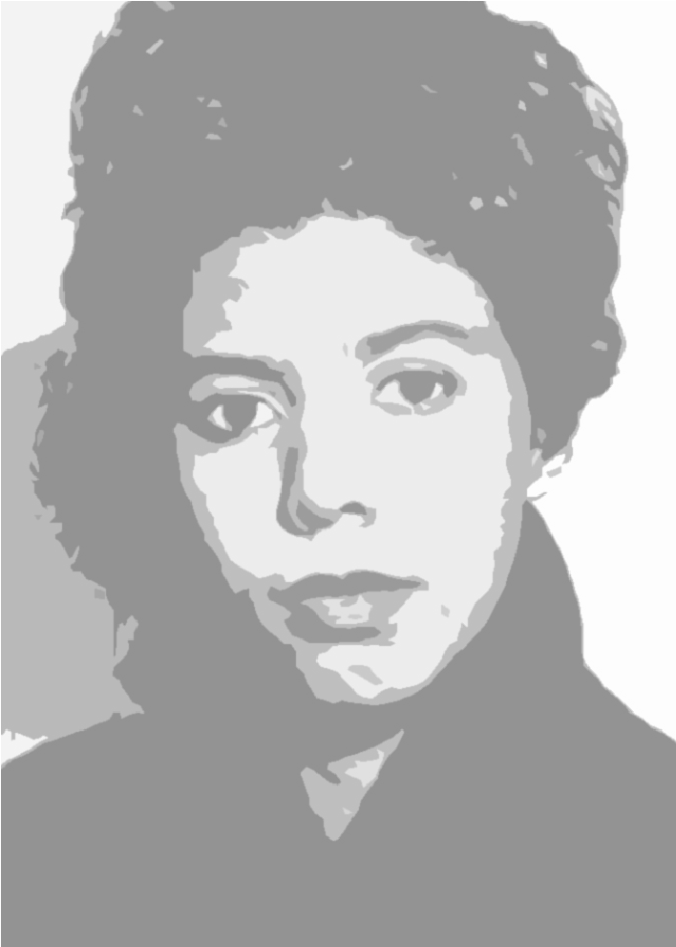
Date of birth:  Date of death:  Cause of death: | Nationality:
 | Education:
Title of breakout work, the first piece of writing that garnered attention:
When was Hansberry considered a success as a writer? Was she alive then?
Names of two other important works by Hansberry and their genres:  1.  2. |  |  | Two memorable characters created by Hansberry:  1.  2.
Four interesting facts I learned about Lorraine Hansberry:  1.  2.  3.  4.  Source/s of this information: |  | Three adjectives to describe Hansberry’s life:
 |  | Two adjectives to describe Hansberry’s literary works:
One meaningful quote from this author:

Source:
 |  | Describe a personal or professional obstacle Hansberry faced:

