PSY 110: Chapter 2 Assignment
Read the following scenarios. For each one, explain which brain areas and systems are probably being activated in these scenarios. Provide at least three examples for each scenario and use different examples for each scenario.
- Shandra is a painter. She is standing by her easel. The window is open and she can smell the jasmine flowers in her yard. She is painting with her right hand. She can hear her children playing in the background.

- Melanie is a police officer. She is preparing for her rank-advancement exam. It’s late at night. She is reading through some material and viewing pictures related to brutal murder cases. She is drinking coffee and eating a sandwich.
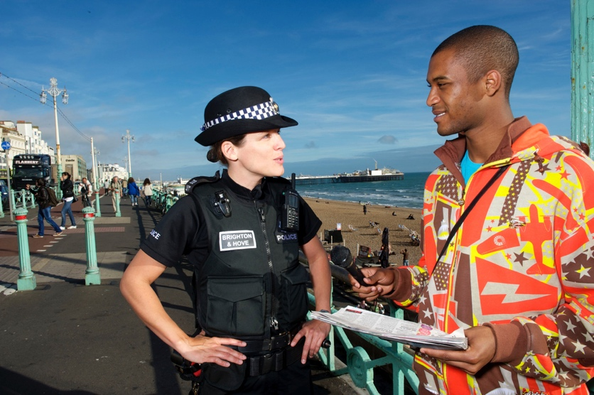

- James is a football player. He is the quarterback in a tough game and the home crowd is yelling and screaming. It’s the fourth quarter, and James is tired and sweating as he goes up to pass the ball. After passing the ball, he and his teammates execute some very complicated running and passing routes to execute a play.

