The Banality of Evil in Indonesia Name ____________________________
English 2E
Date __________ Hour ______

TO REVIEW:
Summarize Arendt’s notion of the banality of evil.

What is the “only effective antidote” to the normalization of human wickedness, according to Popova?

Your task in this lesson: Decide whether or not the phrase banality of evil aptly describes the perpetrators in the event you are going to learn about today.

Our source text: Clips from the controversial Academy Award-nominated film, The Act of Killing.

Film Clip #1 (1:38)

Write down 3 important facts about the historical background for the film, which recounts the 1965 military coup in Indonesia.

Facts about Indonesia:
- Indonesia is the world’s third largest democracy.
- It has the largest Muslim-majority population.
- It is the tenth-largest economy in the world by purchasing power.
- It possesses the world’s greatest marine biodiversity and the second greatest terrestrial biodiversity.
- Indonesia borders the South China Sea, which has the world’s busiest sea lanes -- over $5 trillion in cargo and as much as 50 percent of the world’s oil tankers pass through the South China Sea every year.
- The United States was one of the first countries to establish diplomatic relations with Indonesia in 1949, following its independence from the Netherlands.
- Indonesia’s democratization and reform process since 1998 has increased its stability and security, and resulted in strengthened U.S.-Indonesia relations.
- The United States and Indonesia initiated in 2010 a Comprehensive Partnership to foster consistent high-level engagement on democracy and civil society, education, security, climate, maritime, energy, and trade issues, among others.
Source: US Department of State https://www.state.gov/r/pa/ei/bgn/2748.htm

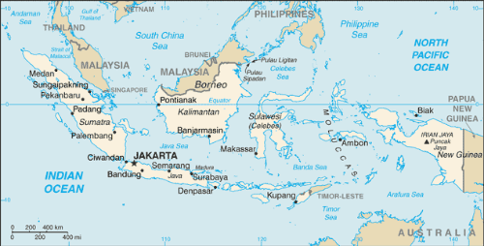

The man featured in the film clips is named Anwar Congo. Remember, your assignment after viewing is to answer the following question: Does Anwar exemplify Arendt's concept of "the banality of evil" or not?

Film Clip #2 (2:20)

Briefly describe what happens in this scene.

Film Clip #3 (2:23)

Explain why Congo says, "It's my mistake."

Questions for Discussion

- How does The Act of Killing build on Arendt's concept? Does Anwar exemplify Arendt's concept of "the banality of evil" or not?

- How does the film deepen your understanding of the nature of humanity? The idea of the performance (i.e., re-enactment) of evil? The pleasures of evil? The trauma of evil?

- Do you think that acts considered evil that are left unpunished draw society into a kind of moral vacuum?

For an extension of these ideas, read “Tribunal Finds Indonesia Guilty of 1965 Genocide; US, UK Complicit,” CNN, http://www.cnn.com/2016/07/21/asia/indonesia-genocide-panel/index.html, July 21, 2016.

In the space below (or on the back of this page), create a visual representation of your response to the main question of the lesson: Does the phrase banality of evil aptly describe the perpetrators in the 1965 Indonesian “Death Squad” activities? You may use a few words or phrases, but try to visually represent your thinking. Rely heavily on figures, shapes, and other visual cues to SHOW what you think.

