To log in to MS Teams:
Go to https://teams.microsoft.com/start
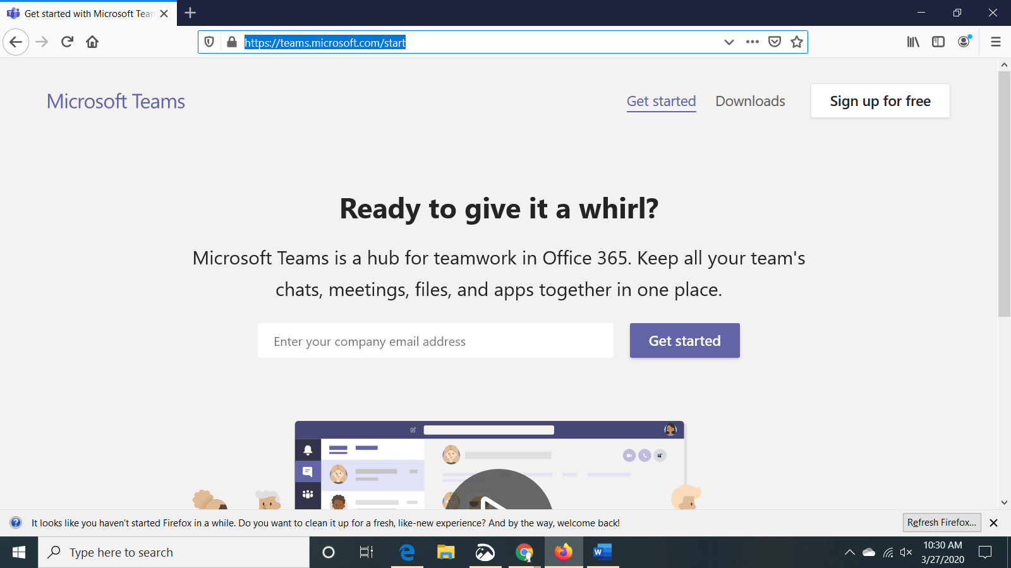
Enter your school email: Lunch Number@students.psd150.org
When this page appears, select school account.
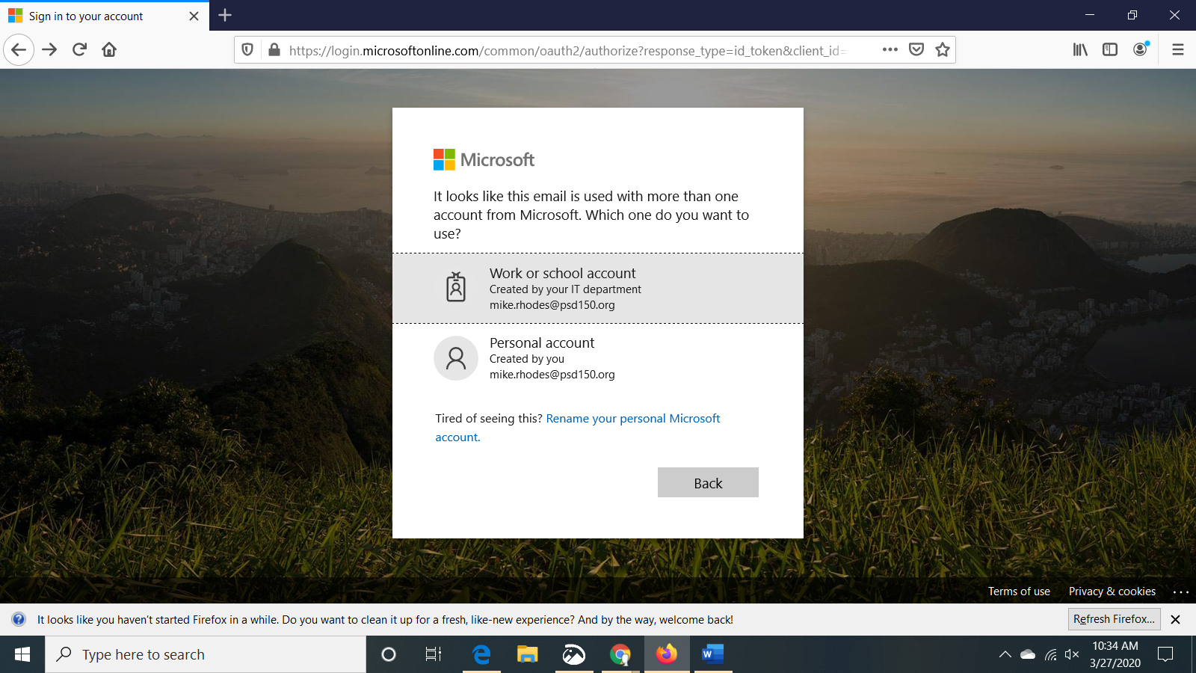
On the next screen enter your date of birth, just like you log in at school:
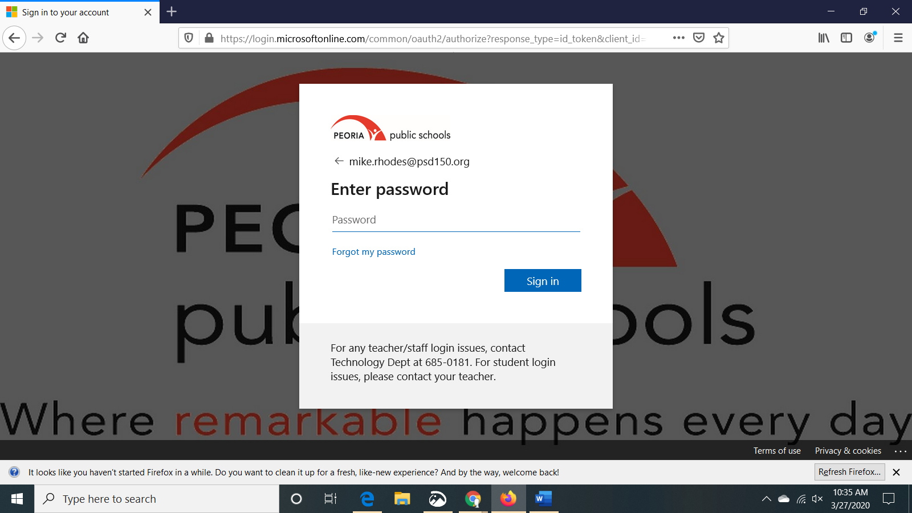
Now you can select each of your classes to check for assignments:
